# 



**Snowell Electric**

**Documentation**

|  |  |
| --- | --- |
| **Authors** | **C2311L- Group 1** |
| **Student1539442- Vũ Việt Hoàng**  **Student1540030- Đào Quốc Vương**  **Student1540012- Đỗ Hoàng Linh**  **Student1529023- Nguyễn Đức Hiệp** |
| **Date** | **19/10/2024** |
| **Instructor** | **Lục Văn Tiến** |

Hanoi, 19/10/2024

**Index**

1. Problem Definition 4

1.1. Problem Abstraction 4

1.2. The Current System 4

1.3. The Proposed System 5

2. Customer Requirements Specification 6

2.1. Users of the System 6

2.2. System functions 7

2.2.1. Register 7

2.2.2. Log In 8

2.2.3. Home 12

2.2.4. Shop Categories 13

2.2.5. Product Detail Page 16

2.2.6. Related Product 17

2.2.7. Shopping Cart 18

2.2.8. Checkout 18

2.2.9. Thank you 19

2.2.10. Store Address 20

2.3. Admin 21

2.3.1. Dashboard 21

2.3.2. Category 23

2.3.3. Brand 26

2.3.4. Product 27

2.3.5. Logout 31

3. System Designs 31

3.1. Entity Relationship Diagram 31

3.2. Database Design 34

3.3. Sitemap 41

3.4. System fucntions design 42

3.4.1. Resgistration 42

3.4.2. Login 43

3.4.3. Checkout 44

4. Task sheet 45

5. Validation Checklists 48

# Problem Definition

## Problem Abstraction

Clarins is a skincare brand for the face and body from France. With a genuine passion for providing natural and authentic beauty solutions, this brand began with a beauty spa and its own product line. With over 60 years of experience in the industry and close interactions with customers, Clarins has become an icon in the field of premium beauty, offering a wide range of skincare solutions for the face and body, makeup, and fragrances. Some of the standout iconic products in their range include various facial oils, the unique Double Serum, and body care treatments that represent the essence of the brand—each product reflecting the professionalism and top-tier effectiveness of Clarins' beauty solutions.

Clarins has been and continues to provide innovative, plant-based solutions. The goal remains unchanged: to seek unique solutions for individual customers. Clarins not only delivers outstanding results but also provides a delightful sensory experience. To achieve this, the product formulas incorporate the best essences from the plant world.

In addition to offering their own products, they also provide products from various other brands on their website. This helps their customers find comprehensive solutions for all skincare and beauty products available on the market.

Your task is to create a Single-Page Application and a Website that meets the specifications below. The website must work well across all major browsers, including Chrome, IE, Firefox, etc.

## The Current System

1. The header of the page must feature an appropriate logo and images of beauty products.
2. The website must contain various sections such as FACE, BODY, SUNSCREEN, HAIR, MAKEUP, PERFUMES, etc., with products displayed in these sections.
3. Clicking on a product will open a pop-up window with detailed information and pricing for the product, along with scrollable images.
4. A filter must be provided based on brand, price, product type, etc.
5. There should be a section displaying different offers on products.
6. Best-selling products should be displayed at the top section.
7. A gallery can be added to view different images.
8. Links to the Site map, Gallery, About Us, and Contact Us must be included.
9. About Us and Contact Us: This menu option must display the organization's email, address, and contact phone number.

In addition to the above, the portal must implement the following functionalities:

* Display a continuously scrolling ticker at the bottom of the page with the current date, time, and location (suggestion: use the geolocation feature of HTML5).
* Display the number of visitors in the upper right corner of the page next to the logo image.
* Menu options must change color on hover and after being clicked.
* Fade-in and fade-out effects can be used for the menus.

## The Proposed System

The new system we are building will be a comprehensive online platform for the Snowell Electric website, providing similar, shopping and convenient experiences for customers. The following are the main functions of the system:

***a***. ***Product:*** Product category - this will be where users search for products. The title bar displays product categories available on the web, including:

- Consumer Electronics

- Home Appliances

- Cooling devices

- Audio Equipment

- Lighting Devices

***b.*** ***The Search bar***: When the user selects a category, the products of that category will display below the title bar. If users want to choose a specific product, they can enter information related to the product into the search bar, and that product will be displayed directly.

***c.*** ***Contact us***: like the contact page, this category will provide contact information, contact forms as well as store address.

***d.*** ***My Cart*** *(Cart)*: This category allows users to check products in the shopping cart to proceed with payment or add/delete products.

***e.*** ***Login***: This category depending on the account can be for website administrators to update the latest product information and edit website details or for buyers to save their information for convenient shopping.***f. Forget password***: This category allows customers to reset their password via email or other authentication methods when they are unable to access their account.

***g.* Accessing**: This notes the number of users currently accessing the site

. Customer Requirements Specification

## Users of the System

* Customer: purchases electronic products.
* Admin: Manages the website and product listings.
* Guest: Browse the website without logging in.

The usages of the website to the clients:

* Browsing products: explore a range of electronic with categories and filters.
* Viewing product details: access detailed product info, specs, pricing and reviews.
* Account management: create / manage accounts, update info and view purchase history.
* Shopping cart: add / update / remove items with cart retention for logged-in users.
* Check-out process: secure checkout with multiple payment options and order review.
* Order tracking and history: track orders and access order history with detailed summaries.
* Customer reviews and ratings: leave and read product reviews and ratings.

## System functions

### Register

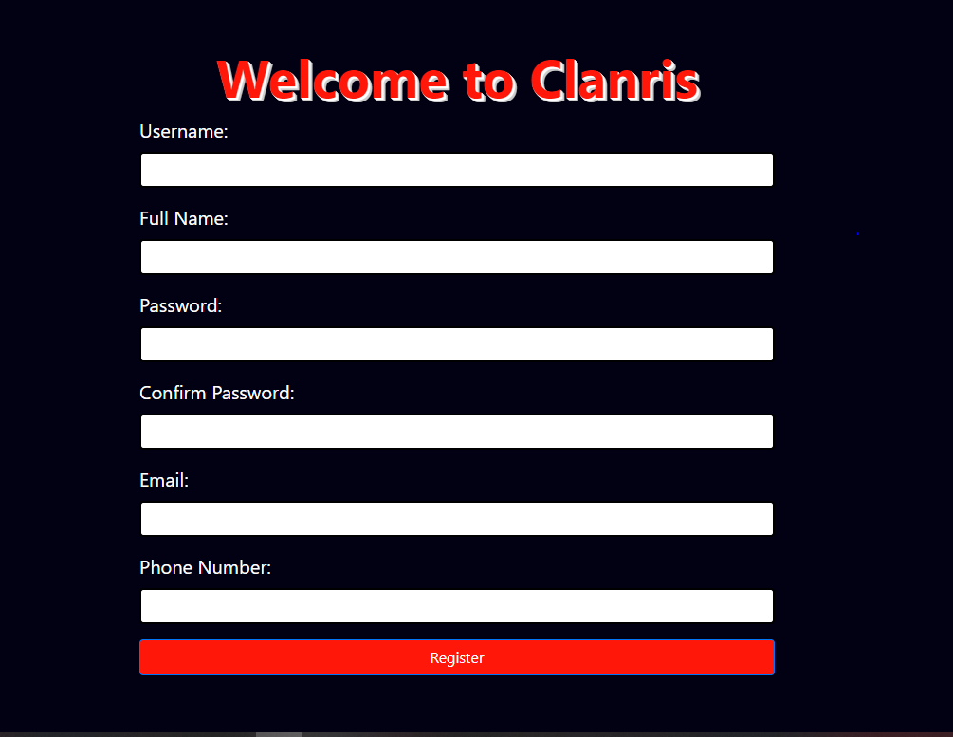

* Display registration interface.
* There are 6 pieces of information, that the user needs to enter.
* Performs data validation in cells:
* The username and password need to have more than 3 characters.
* The password needs to be confirmed.
* The email and phone number need to be in the correct format.
* Click the “Signup” button to register. If the above requirements are wrong or information doesn’t unique, an error message will be displayed.

### Log In

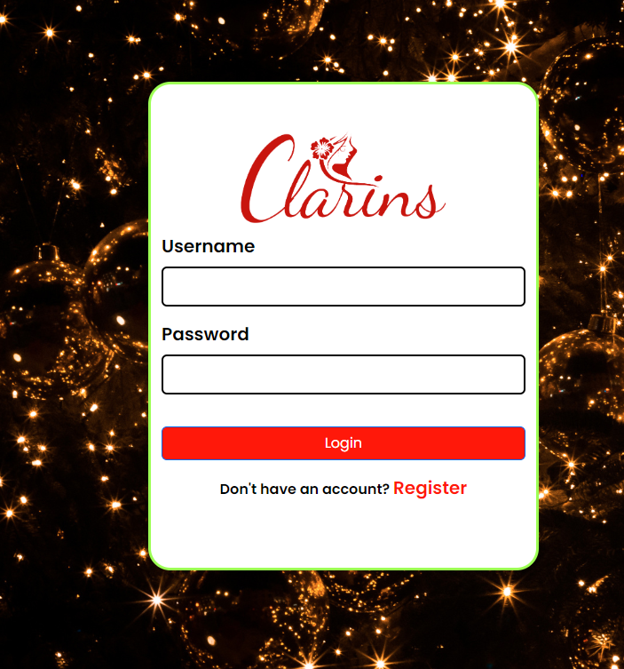

* Display the login interface.
* Users will enter the information including email and password.
* Next, click on the “Login” button and the system check:

1. Have you filled in all the information?

2. Is your login information correct? (the same as the information registered by the user)

* If one of the above two factors is wrong, the system will report an error. If the opposite is true, login will be allowed.
* If the user don’t have an account yet, then click on the “Register”, the system will turn into Register Interface.

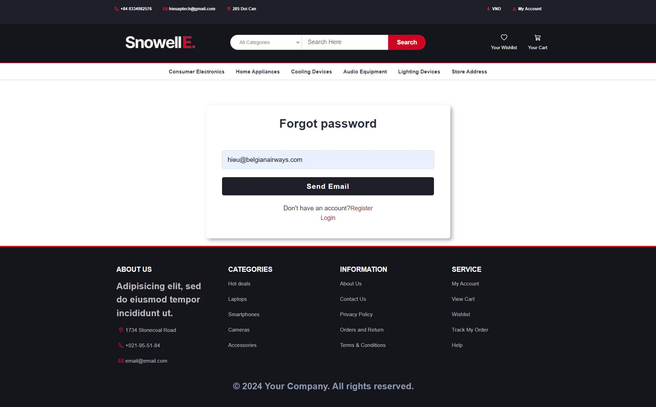

* Display the forgot password interface.
* Users will enter the information including email.
* Next, click on the “Send Email” button and the system checks:

1. Have you filled in all the information?
2. Is your email registered in the system?

* If one of the above two factors is wrong, the system will report an error. If the opposite is true, an email to reset the password will be sent.
* If the user doesn’t have an account yet, click on the “Register”, the system will turn into Register Interface.
* If the user remembers the password, click on the “Login”, the system will turn into Login Interface.

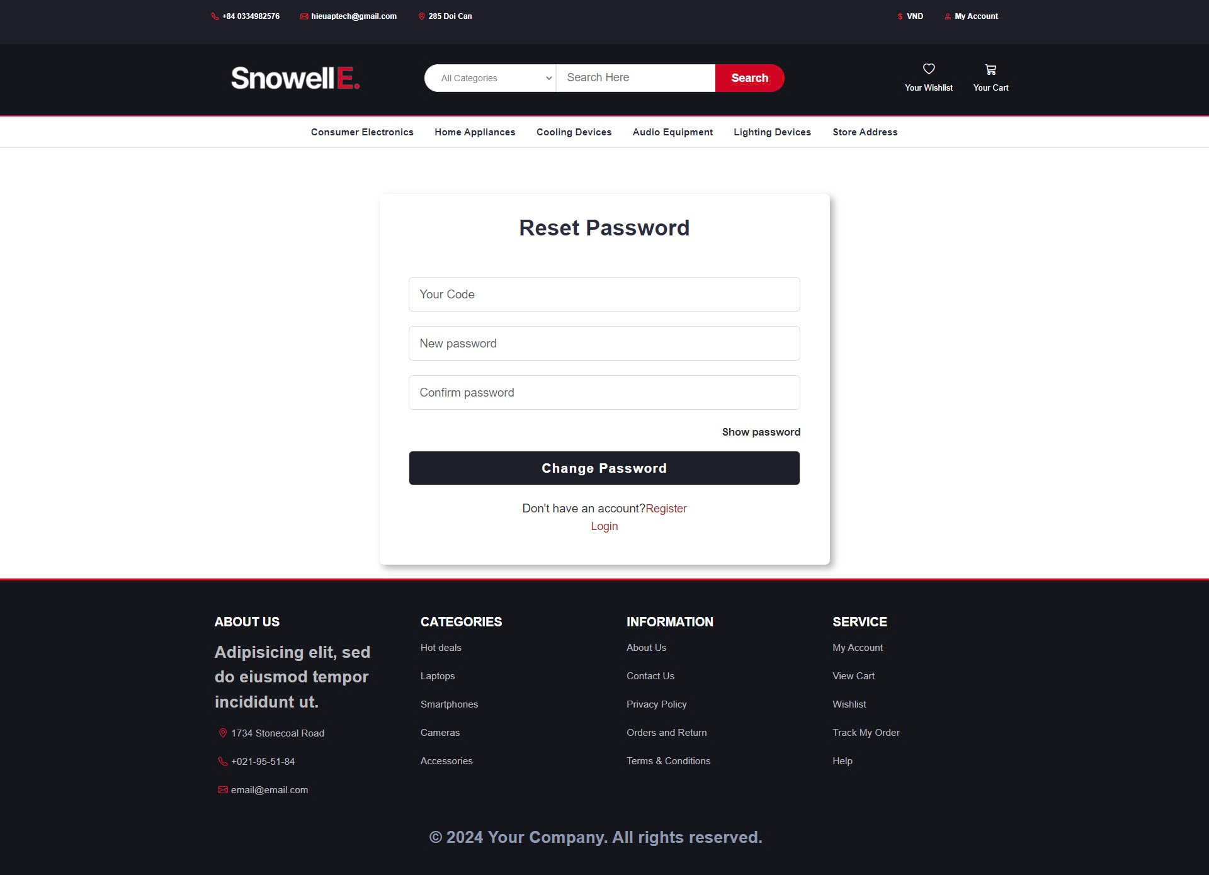

This interface shows:

**Reset Password**:

* Display the reset password interface.
* Users will enter the information including the reset code, new password, and confirm password.
* Next, click on the “Change Password” button and the system checks:
  1. Have you filled in all the information?
  2. Do the new password and confirm password match?
* If one of the above two factors is wrong, the system will report an error. If the opposite is true, the password will be reset.
* If the user doesn’t have an account yet, click on the “Register”, the system will turn into Register Interface.
* If the user remembers the password, click on the “Login”, the system will turn into Login Interface.

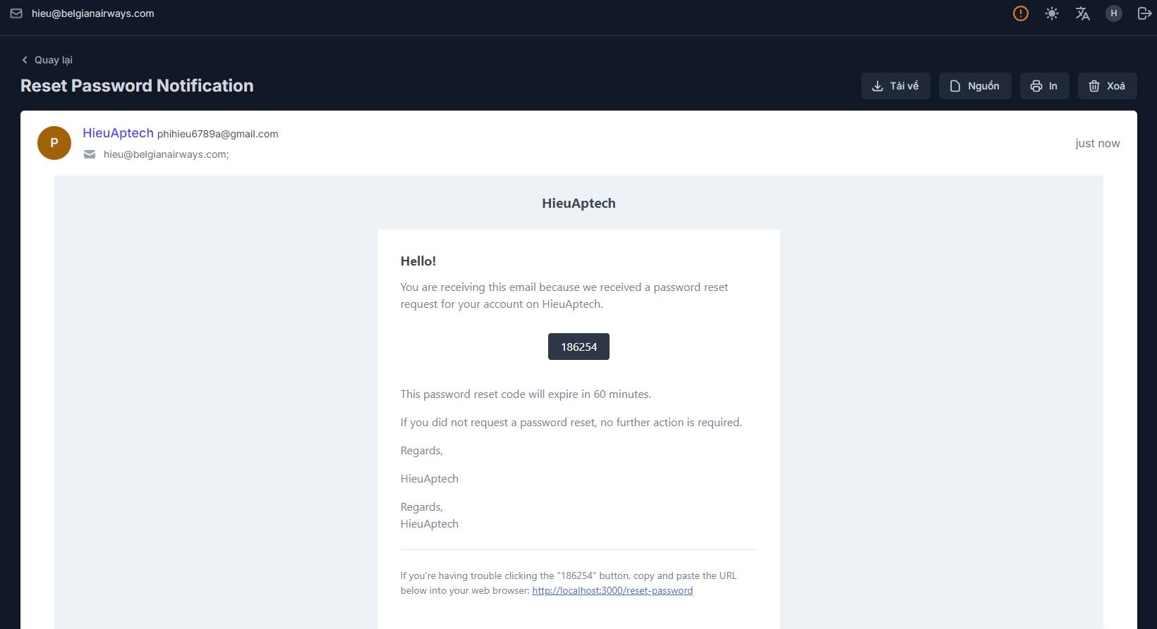

This interface shows:

**Reset Password Notification**:

* **Display the reset password notification email interface.**
* **The email includes**:
  + **Greeting**: "Hello!"
  + **Message**: Notification about receiving a password reset request for the user's account.
  + **Reset Code**: A unique code (e.g., 186254) for resetting the password.
  + **Expiration**: Information that the reset code will expire in 60 minutes.
  + **No Action Required**: Instruction that no further action is needed if the password reset was not requested by the user.
  + **Signature**: Regards from the service team.
  + **Help Link**: A URL to reset the password directly if the code button does not work.

The email provides the necessary information and instructions for resetting the password securely.

### Home

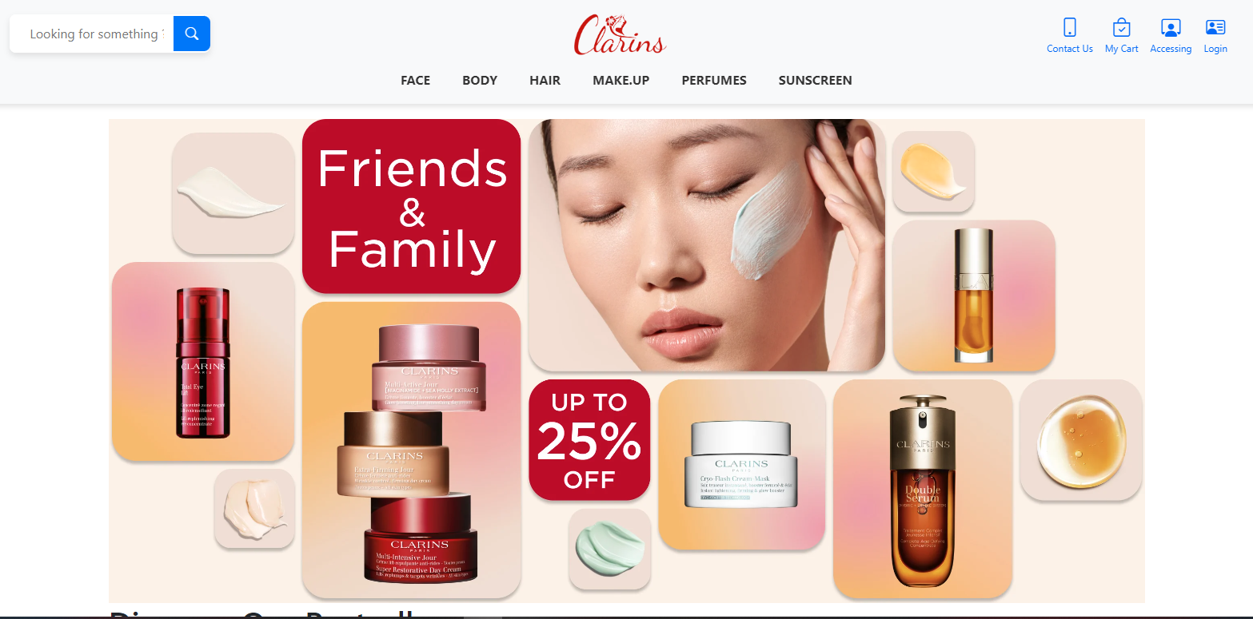

* + Customers can register and then log in to shop or can shop without logging in
  + There are 2 options: Log in and Register

### Shop Categories

#### Consumer Electronics

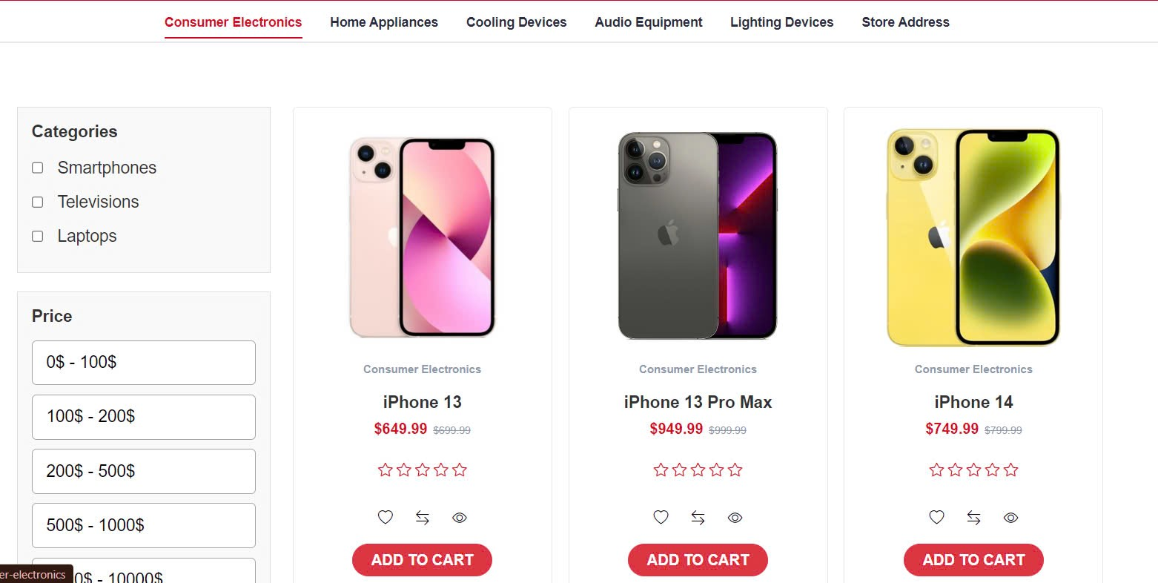

* Client must register and then sign in to shopping
  + These are electronic product categories such as: Smartphone, Televisions, Laptops.
  + Admin can be able to create new products.
  + There are the filter bar for searching price.
  + When a customer sign in successfully and find the product that they like => Click button Add to Cart

#### Home Appliances

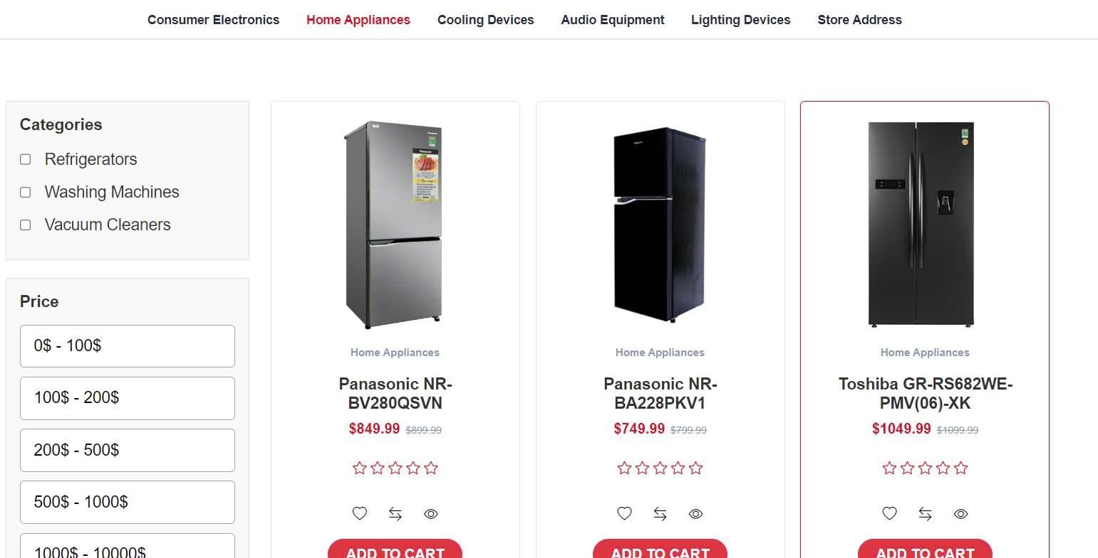

* Client must register and then sign in to shopping
  + These are home appliance categories such as: Refrigerators, Washing Machines, Vacuum Cleaners.
  + Admin can be able to create new products.
  + There are the filter bar for searching price.
  + When a customer sign in successfully and find the product that they like => Click button Add to Cart

#### Cooling Devices

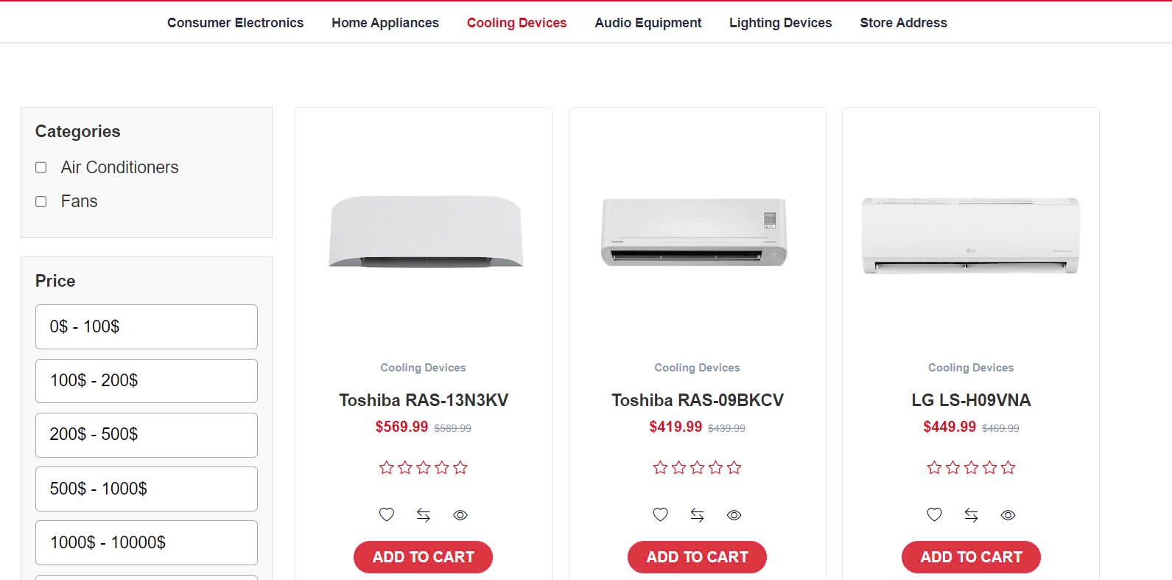

* Client must register and then sign in to shopping
  + These are cooling device categories such as: As Conditioners, Fans.
  + Admin can be able to create new products.
  + There are the filter bar for searching price.
  + When a customer sign in successfully and find the product that they like => Click button Add to Cart

#### Audio Equipment

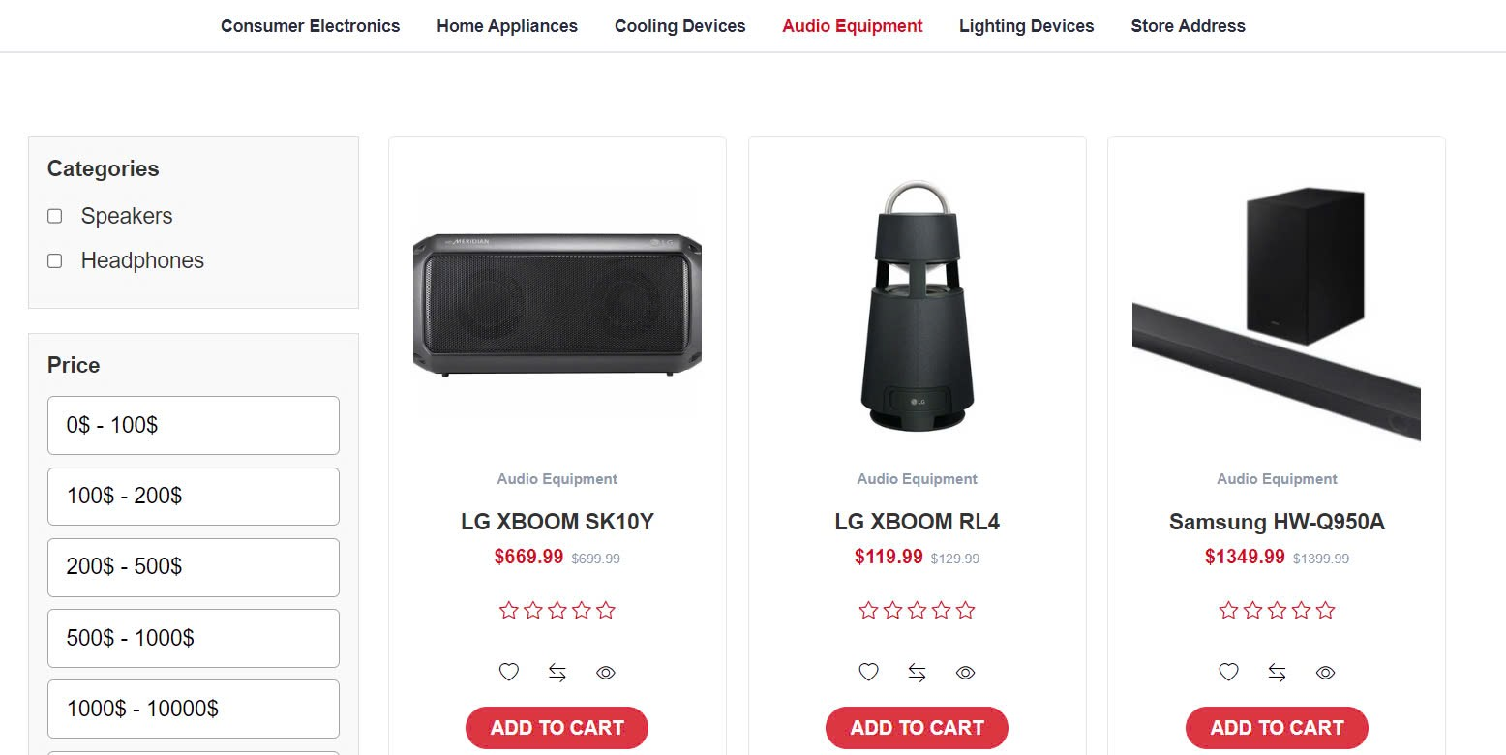

* Client must register and then sign in to shopping
  + These are audio equipment categories such as: Speakers, Headphones.
  + Admin can be able to create new products.
  + There are the filter bar for searching price.
  + When a customer sign in successfully and find the product that they like => Click button Add to Cart

#### Lightning Devices

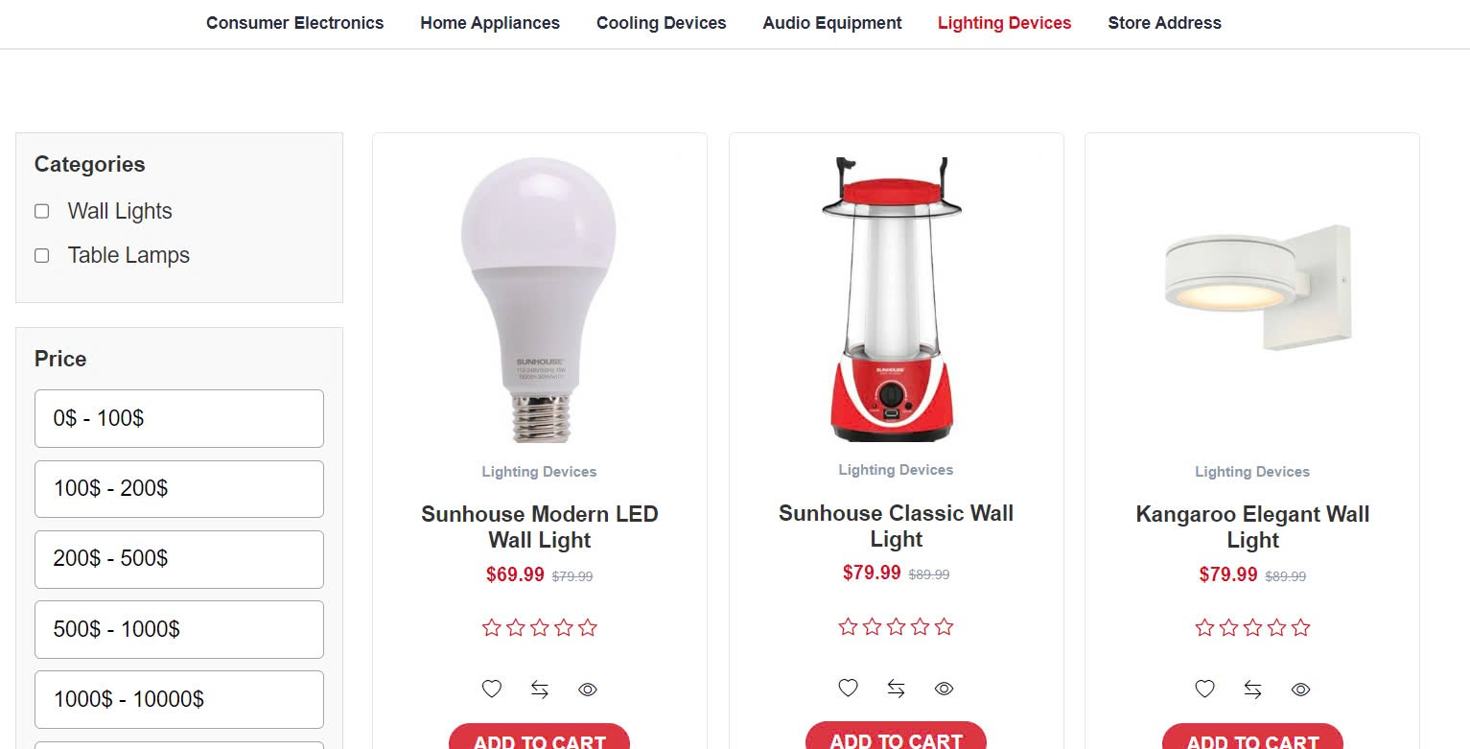

* Client must register and then sign in to shopping
  + These are lightning device categories such as: Wall Lights, Table Lamps.
  + Admin can be able to create new products.
  + There are the filter bar for searching price.
  + When a customer sign in successfully and find the product that they like => Click button Add to Cart

### Product Detail Page

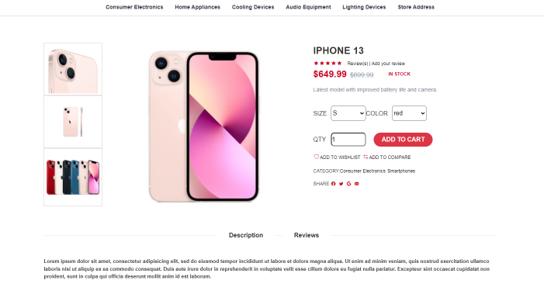

Some products have multiple color and size options, customer can find the color that they want by clicking on the color or size bar

Choose and edit the quantity

Clients can also choose other products in the same category.

They can also share their favourite product on social media like: Facebook, Twitter, Google or share them to friends via Email.

### Related Product

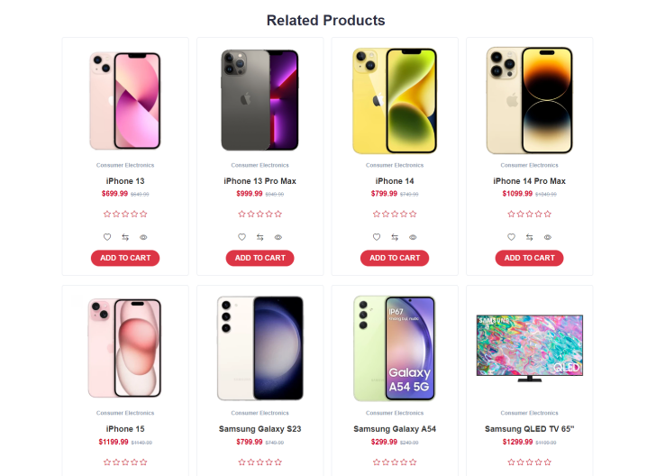

The clients can choose related products under the product detail page.

There are multiple products as the same category or relevant products to help the website reach out more demands

### Shopping Cart

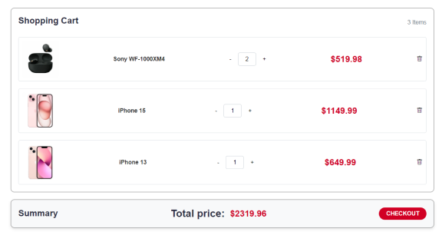

This interface will show the items that the client chose with the quantity, the price.

The client can also edit the quantity they want to buy or delete the item that they don’t want to purchase at the moment.

The table will show the summary of total price.

After checking all the details, the client can be able to pay by click to the button “Checkout”.

### Checkout

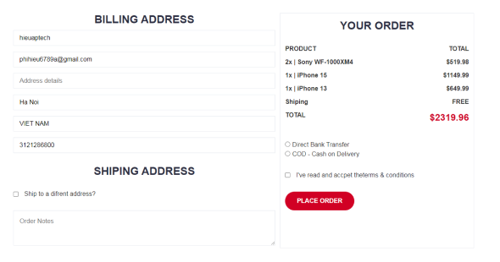

This interface will show the detail of billing address with 6 information bars include: name, email, address detail, city, country, phone number.

The right table will finalize the order of the clients.

Shipping address will show the blank space for the clients to fill up if they have any other request or the products should be delivered to another address that different to the address detail.

After the clients check all the details and information, they have to tick a check mark to a box that included terms and conditions

Then click the button “Place Order” to checkout to turn into the “Thank you” interface.

### Thank you

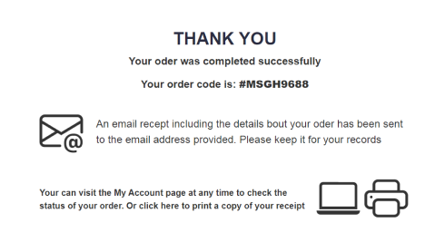

After checkout, the website will show the “Thank you” interface to give an appreciation to the guest that bought the products with the successfully confirmation and the order code.

Also this confirmation will be sent to the guest’s email address to track the order.

The clients can also be able to check the status of the order by click to “My Account” or print a receipt as a copy by click to “click here” link.

### Store Address

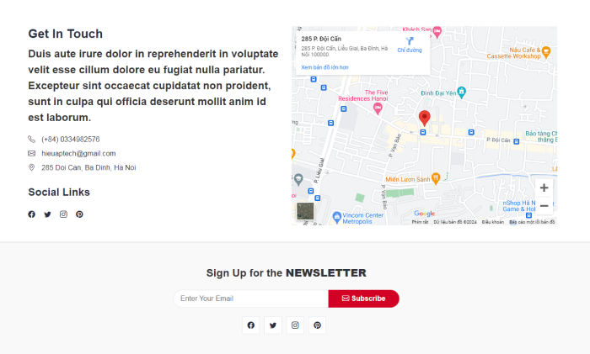

By click onto the navigation bar with the button “Store Address”, the clients can see the Contact Us interface.

This interface will display the text “Get in touch” with the website information included phone number, contact email and address.

There is also contact via social networking sites such as Facebook, Twitter, Instagram and Pinterest.

## Admin

### Dashboard

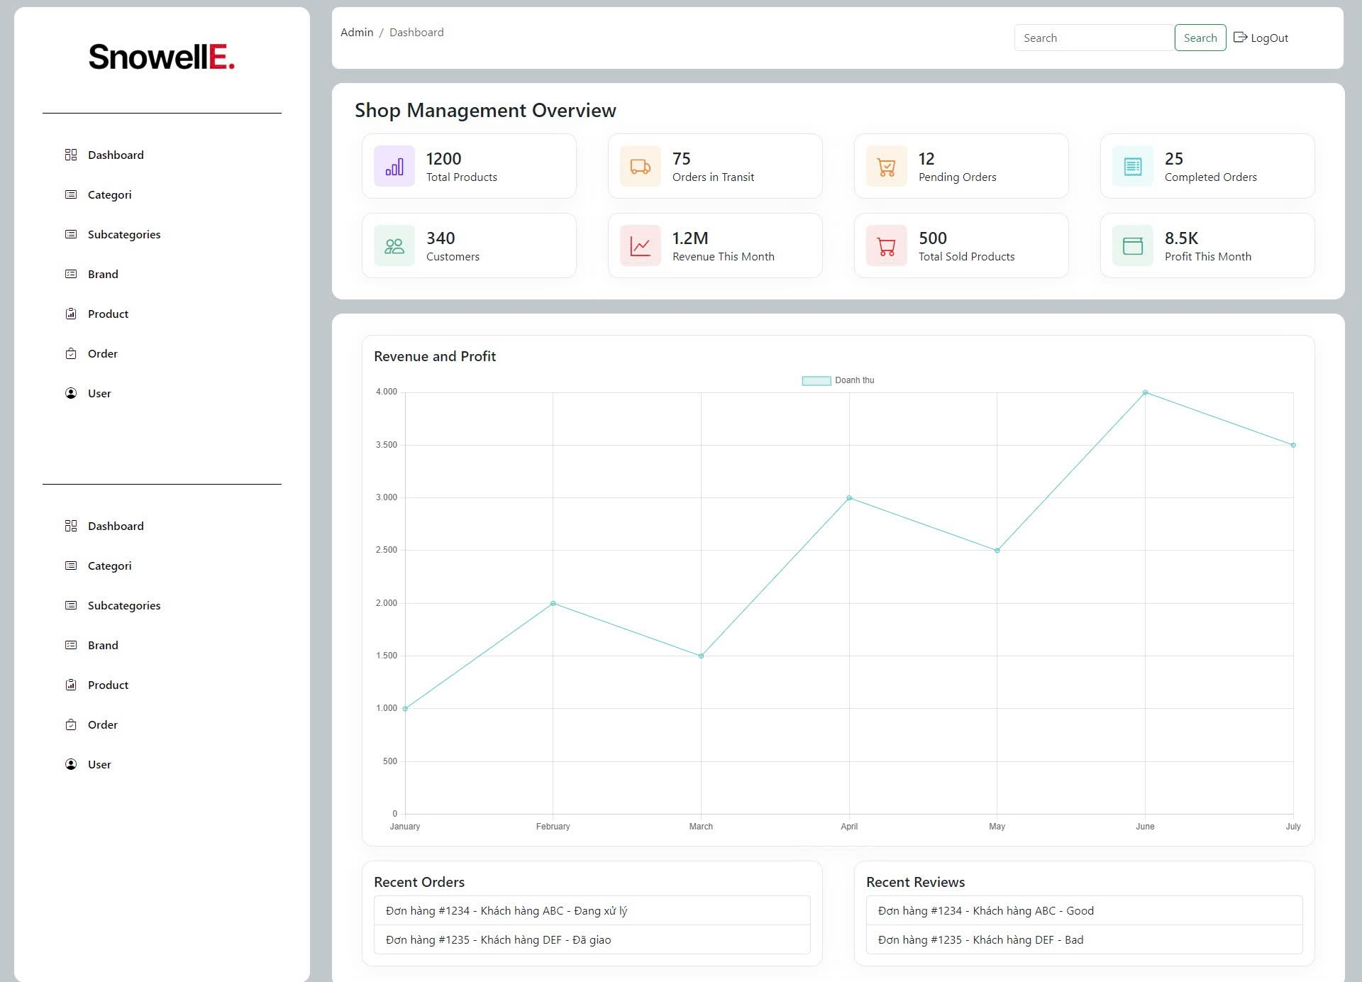

The dashboard shows:

1. **Shop Management Overview**
   * Total Products
   * Orders in Transit
   * Pending Orders
   * Completed Orders
   * Customers
   * Revenue This Month
   * Total Sold Products
   * Profit This Month
2. **Revenue and Profit**
   * Line chart showing revenue trends
3. **Recent Orders**
   * List of recent orders with status
4. **Recent Reviews**
   * List of recent customer reviews

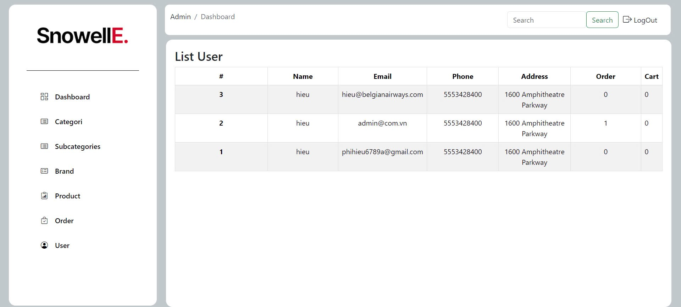

This interface shows:

**List User**:

**#**: User ID or rank.

**Name**: User's name.

**Email**: User's email address.

**Phone**: User's phone number.

**Address**: User's address.

**Order**: Number of orders placed by the user.

**Cart**: Number of items in the user's cart.

### Category

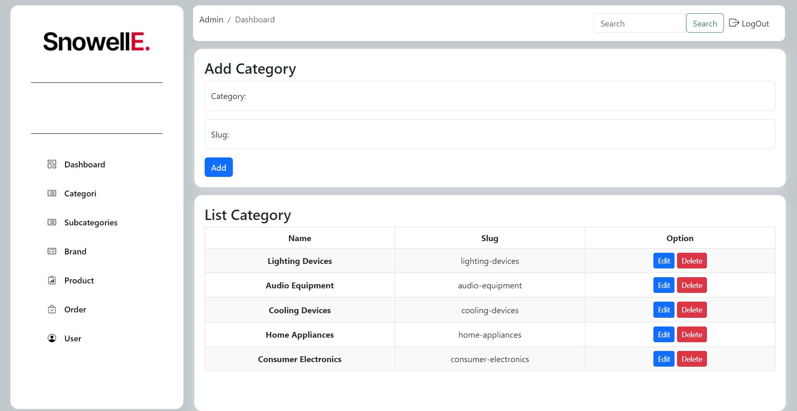

This category interface shows:

Add Category:

Input fields for "Category" and "Slug"

"**Add**" button to create a new category.

List Category:

Displays existing categories with columns for "Name" and "Slug".

Options to "Edit" and "Delete" each category.

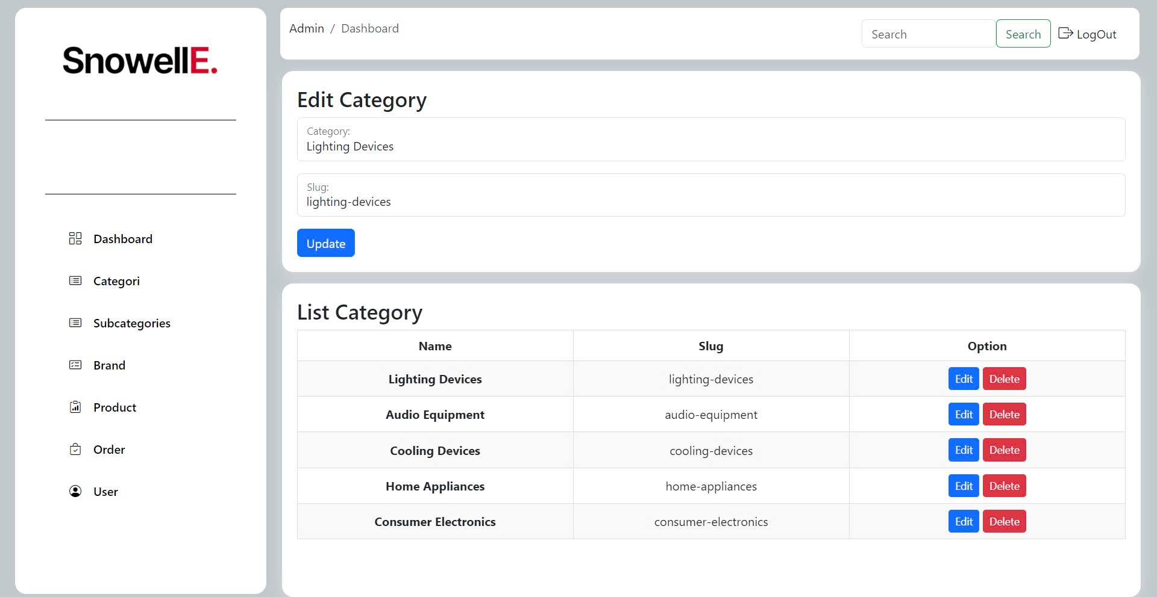

This interface shows:

**Edit Category**:

**Category**: Input field to enter the name of the category name.

**Slug:** Input field to enter or update the slug.

**Update Button** : Button to save changes.

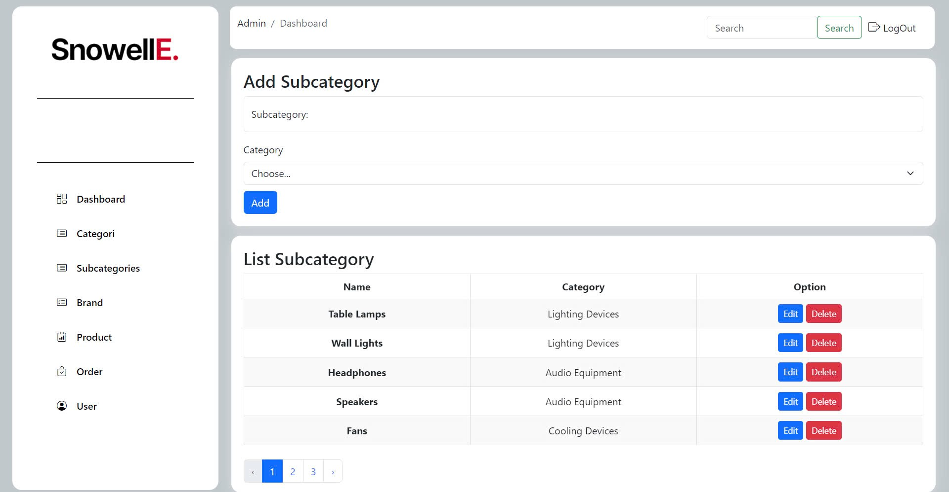

This interface shows:

**Add Subcategory**:

**Subcategory**: Input field to enter the name of the subcategory.

**Category**: Dropdown menu to select the main category to which the subcategory belongs.

**Add Button**: Button to add the new subcategory.

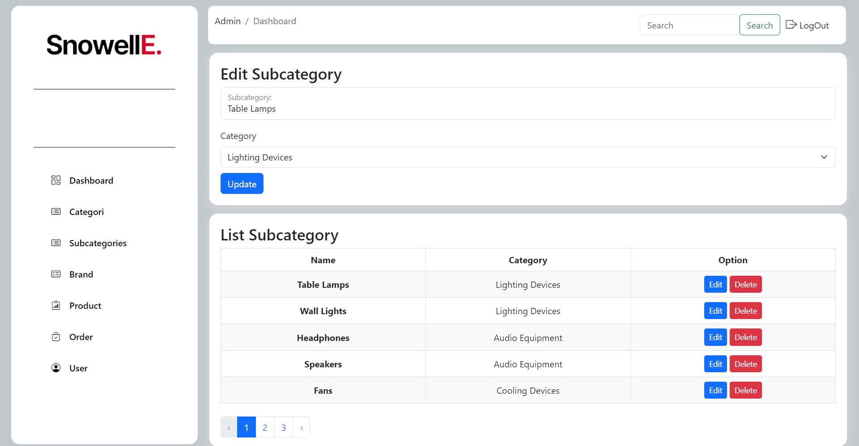

This interface shows:

**Edit Subcategory**

**Subcategory**: Input field to enter the name of the subcategory.

**Category**: Dropdown menu to select the main category to which the subcategory belongs.

**Update Button**: Button to save changes.

### Brand

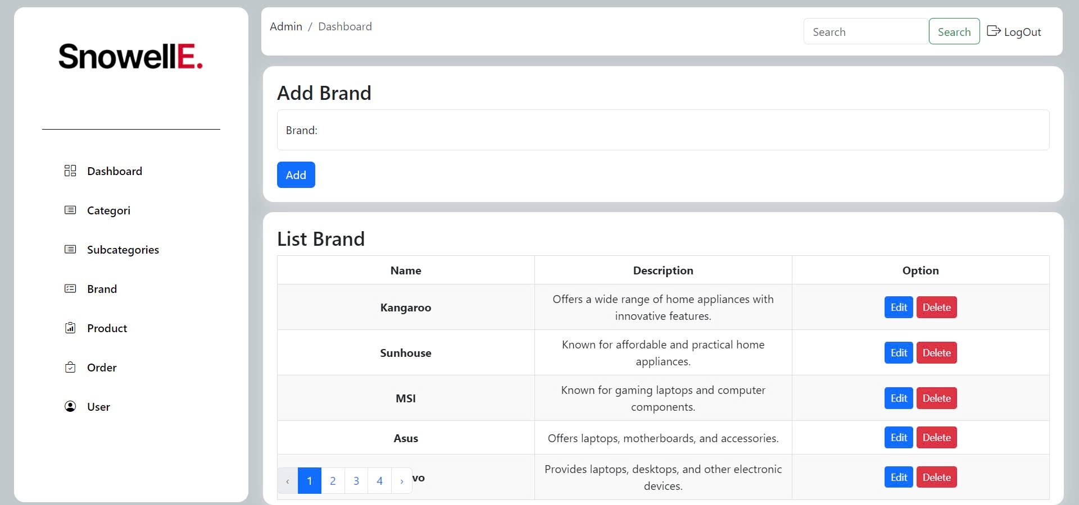

This interface shows:

**Add Brand**:

**Brand**: Input field to enter the brand name.

**Add Button**: Button to add the new brand.

**List Brand**:

**Name**: Name of the brand.

**Description**: Brief description of the brand.

**Option**: Buttons to "Edit" and "Delete" the brand.

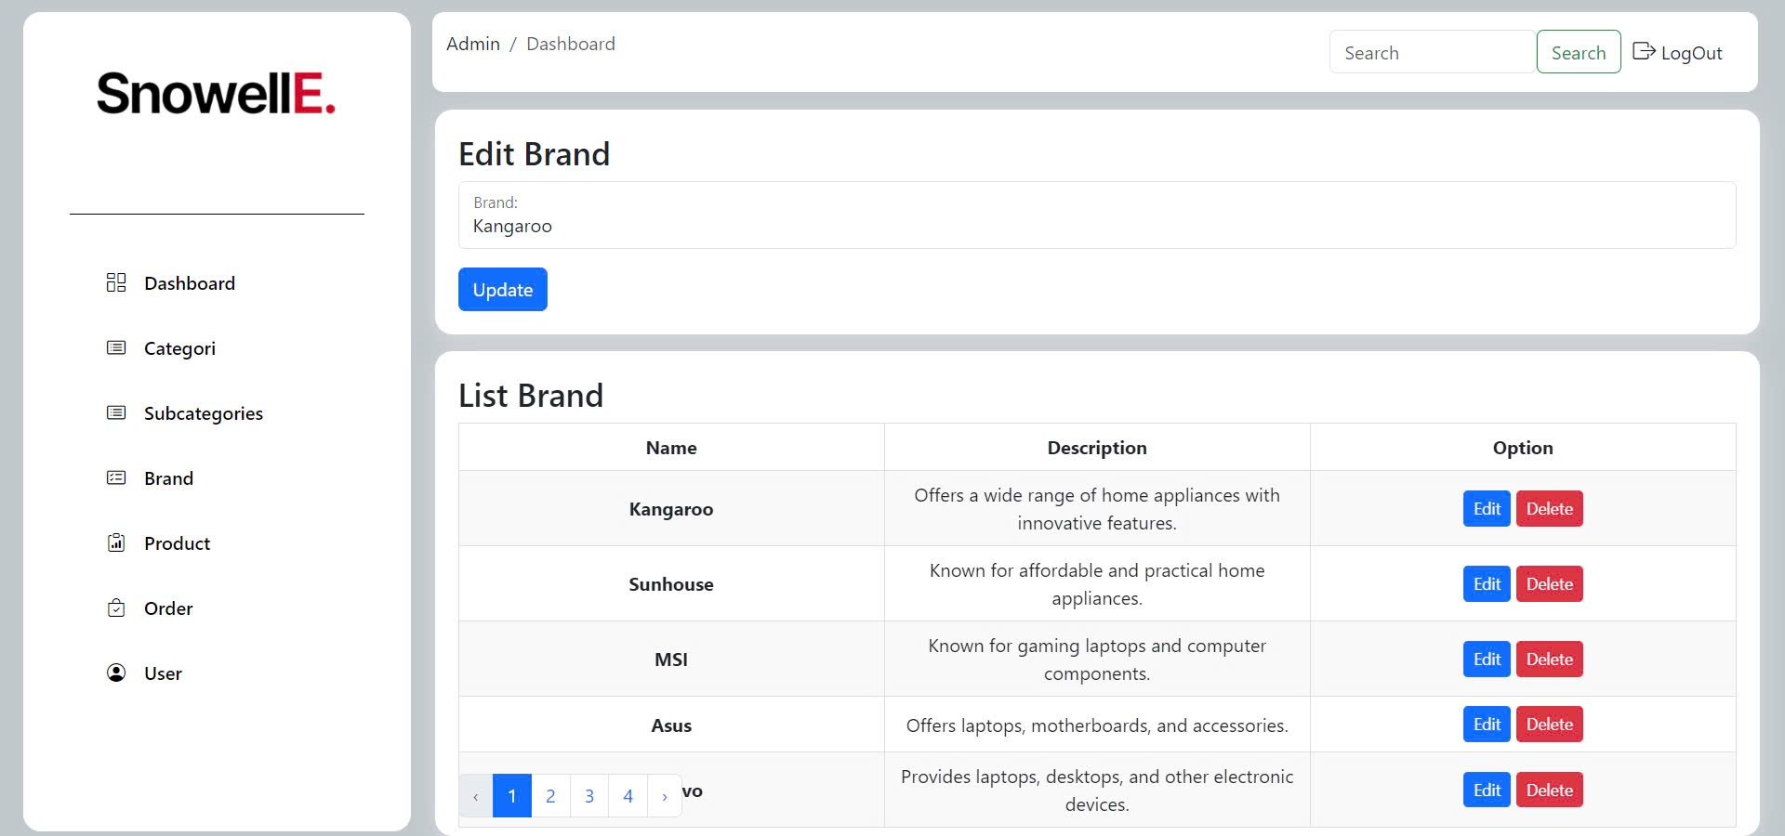

This interface shows:

**Edit Brand**:

**Brand**: Input field to enter or update the brand name.

**Update Button**: Button to save changes.

### Product

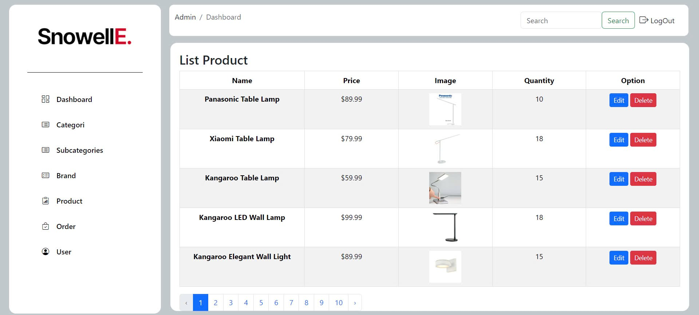

This interface shows:

**List Product**:

**Name**: Name of the product.

**Price**: Price of the product.

**Image**: Thumbnail image of the product.

**Quantity**: Number of items available in stock.

**Option**: Buttons to "Edit" and "Delete" the product.

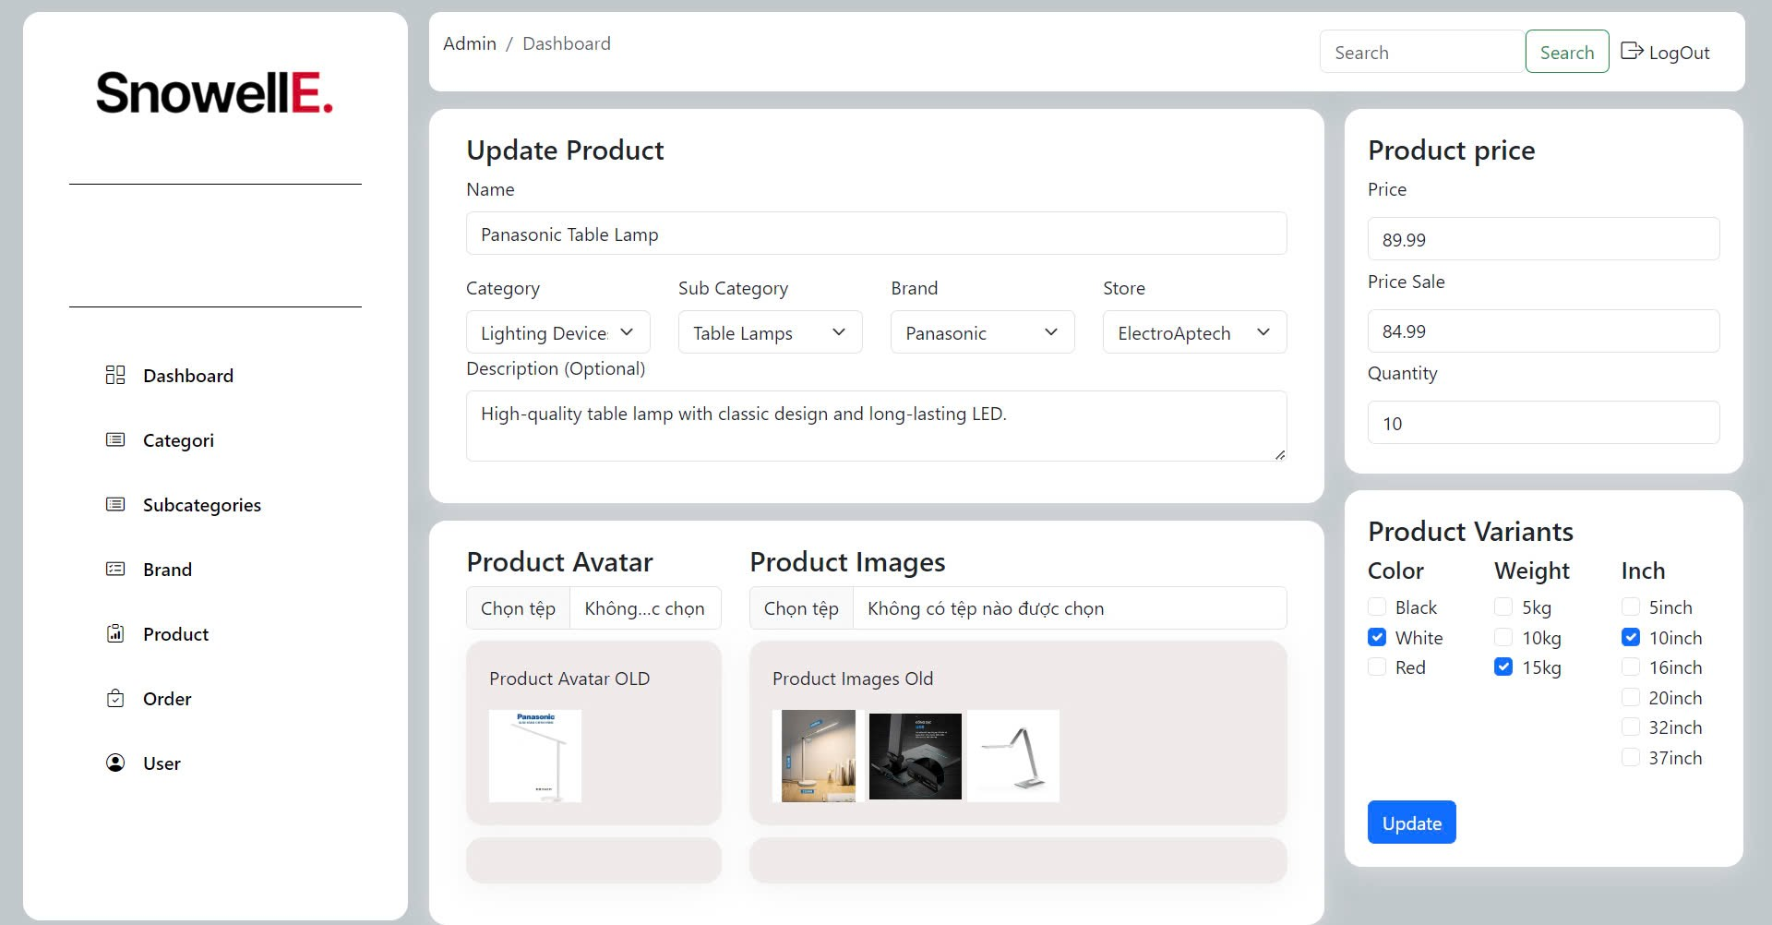

This interface shows:

**Update Product**:

**Name**: Input field to update the product name.

**Category**: Dropdown menu to select the main category.

**Sub Category**: Dropdown menu to select the subcategory.

**Brand**: Dropdown menu to select the brand.

**Store**: Dropdown menu to select the store.

**Description (Optional)**: Input field to add or update the product description.

***Product Avatar****:*

**Choose File**: Option to upload a new product avatar image.

**Product Avatar Old**: Display of the current product avatar image.

***Product Images****:*

**Choose File**: Option to upload new product images.

**Product Images Old**: Display of the current product images.

***Product Price****:*

**Price**: Input field to update the product price.

**Price Sale**: Input field to update the sale price.

**Quantity**: Input field to update the quantity available. ***Product Variants****:*

**Color**: Checkboxes to select available colors.

**Weight**: Checkboxes to select available weights.

**Inch**: Checkboxes to select available sizes.

**Update Button**: Button to save all changes.

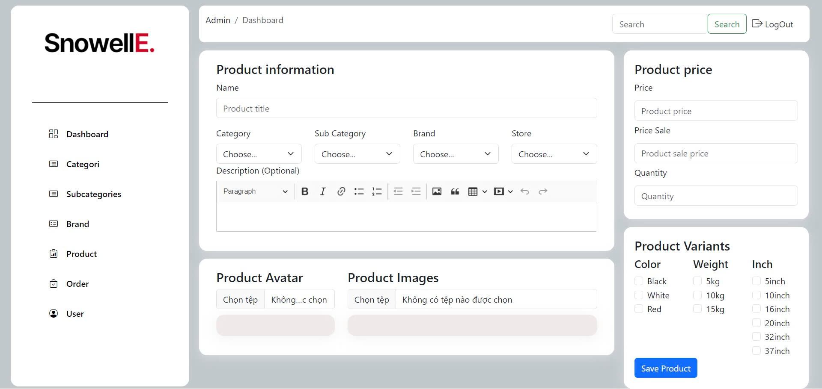

This interface shows:

**Product Information**:

**Name**: Input field for the product title.

**Category**: Dropdown menu to select the main category.

**Sub Category**: Dropdown menu to select the subcategory.

**Brand**: Dropdown menu to select the brand.

**Store**: Dropdown menu to select the store.

**Description (Optional)**: Input field for the product description with rich text formatting options.

**Save Product**:

**Save Product Button**: Button to save all product information and updates.

The same parts are also mentioned above.

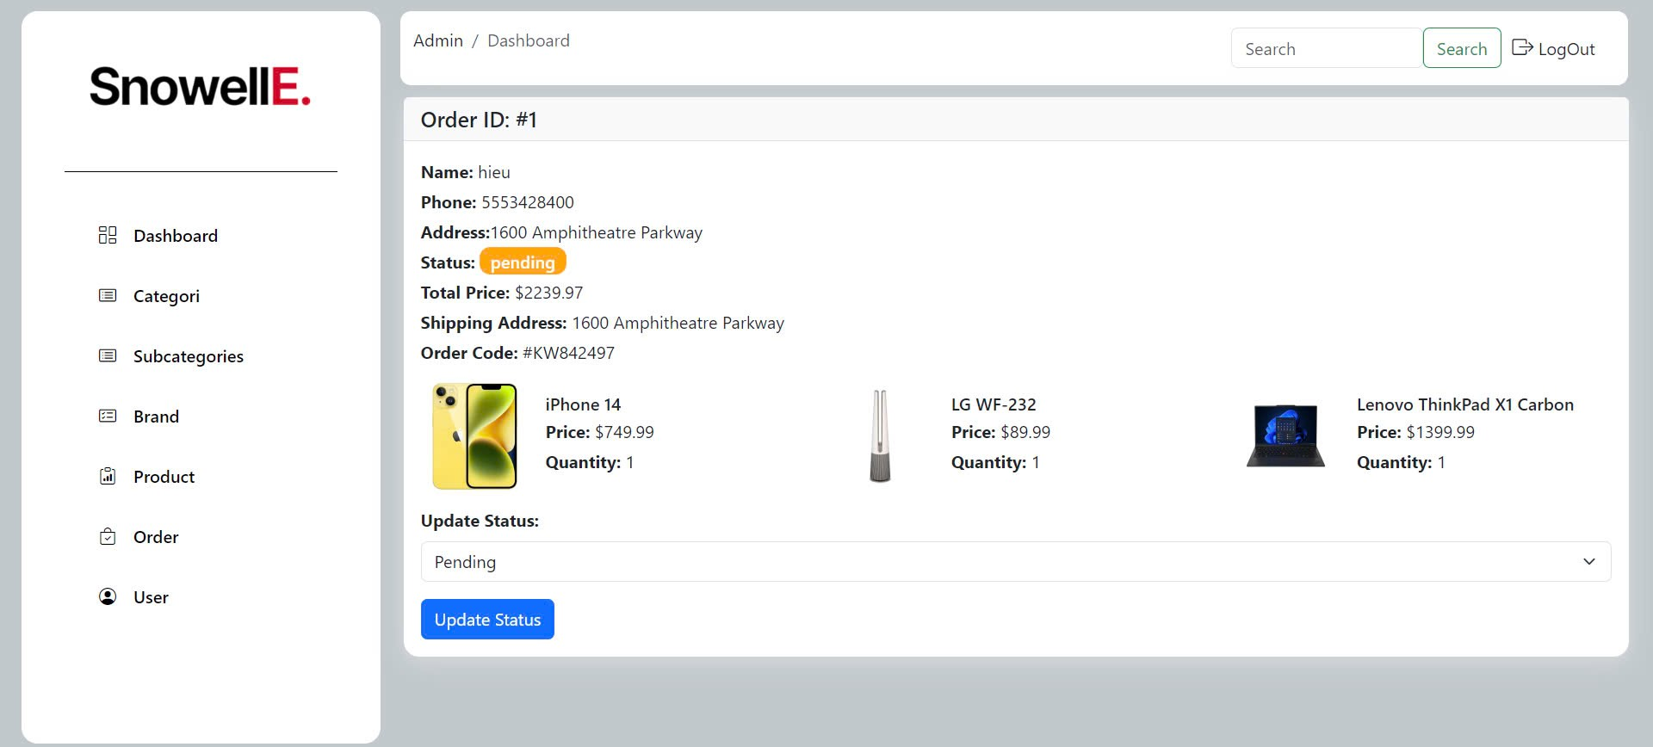

This interface shows:

***Order Details****:*

**Order ID**: Displays the order ID (e.g., #1).

**Customer Information**:

**Name**: Customer's name.

**Phone**: Customer's phone number.

**Address**: Customer's address.

***Order Status****:*

**Status**: Current order status (e.g., pending).

**Update Status**: Dropdown menu to change the order status.

**Update Status Button**: Button to save the status update.

***Order Summary****:*

**Total Price**: Total cost of the order.

**Shipping Address**: Address where the order will be shipped.

**Order Code**: Unique code for the order.

***Products Ordered****:*

**Product Details**: Displays each product's name, price, and quantity (Example products)

### 2.3.5. Logout

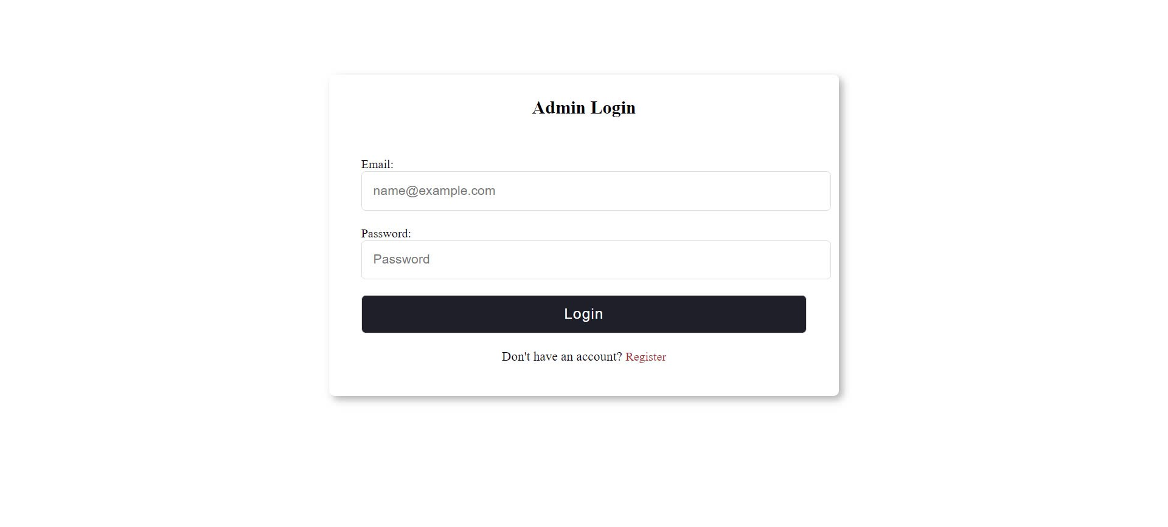

This interface shows:

**Admin Login**:

**Email**: Input field for the admin's email address.

**Password**: Input field for the admin's password.

**Login Button**: Button to submit the login credentials.

**Register Link**: Link to the registration page for new accounts.

# System Designs

## Entity Relationship Diagram

With the objective of creating a website that integrates information provision with e-commerce, we identify the entities that the website needs:

* Homepage:

- Header:

+ Search Bar

+ Cart

+ Login

- List categories Products

+ Consumer Electronic

+ Home Appliances

+ Cooling Devices

+ Audio Equipment

+ Lighting Devices

+ Store Address

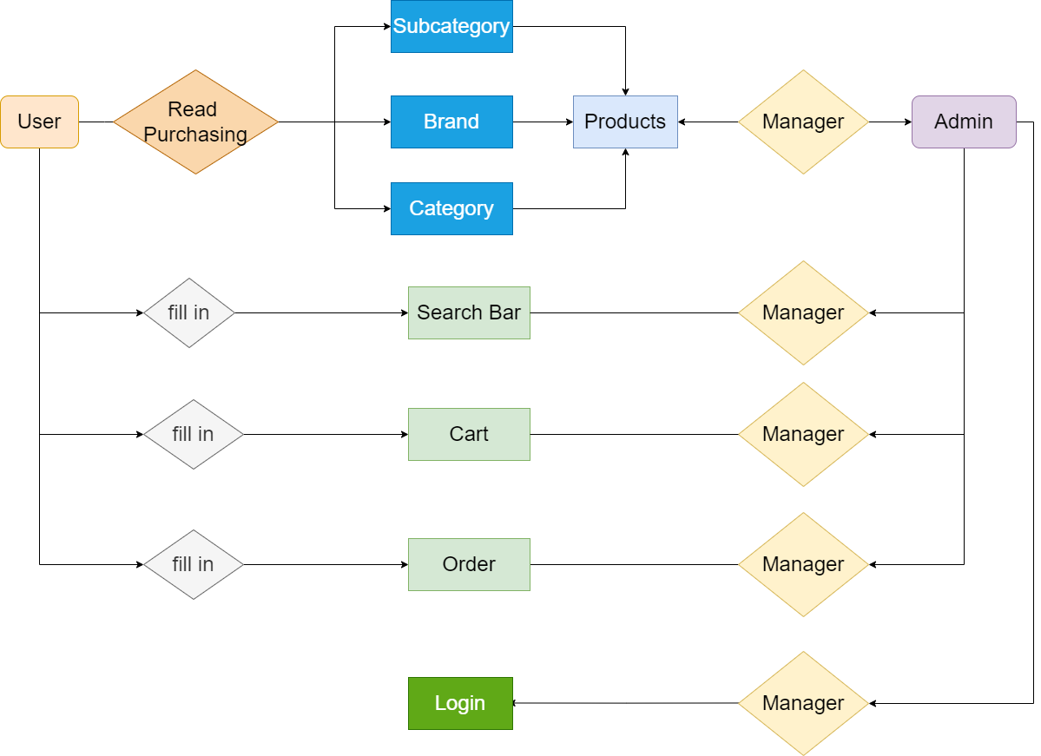

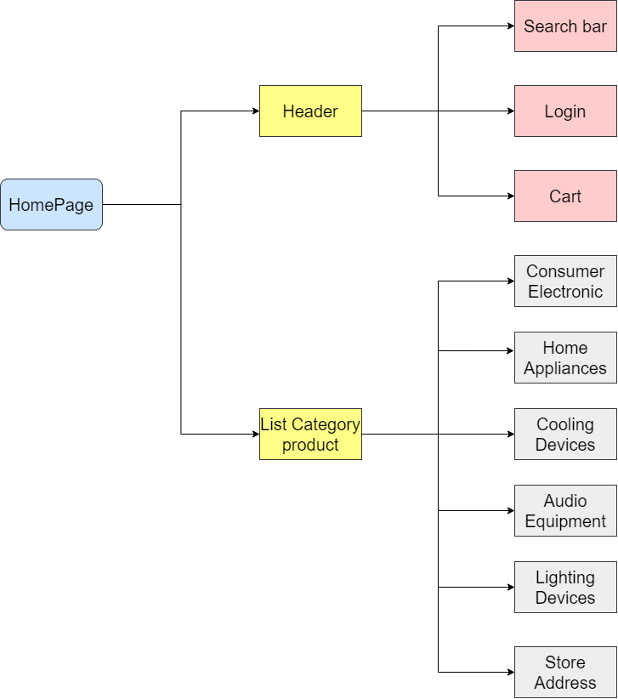

## Database Design

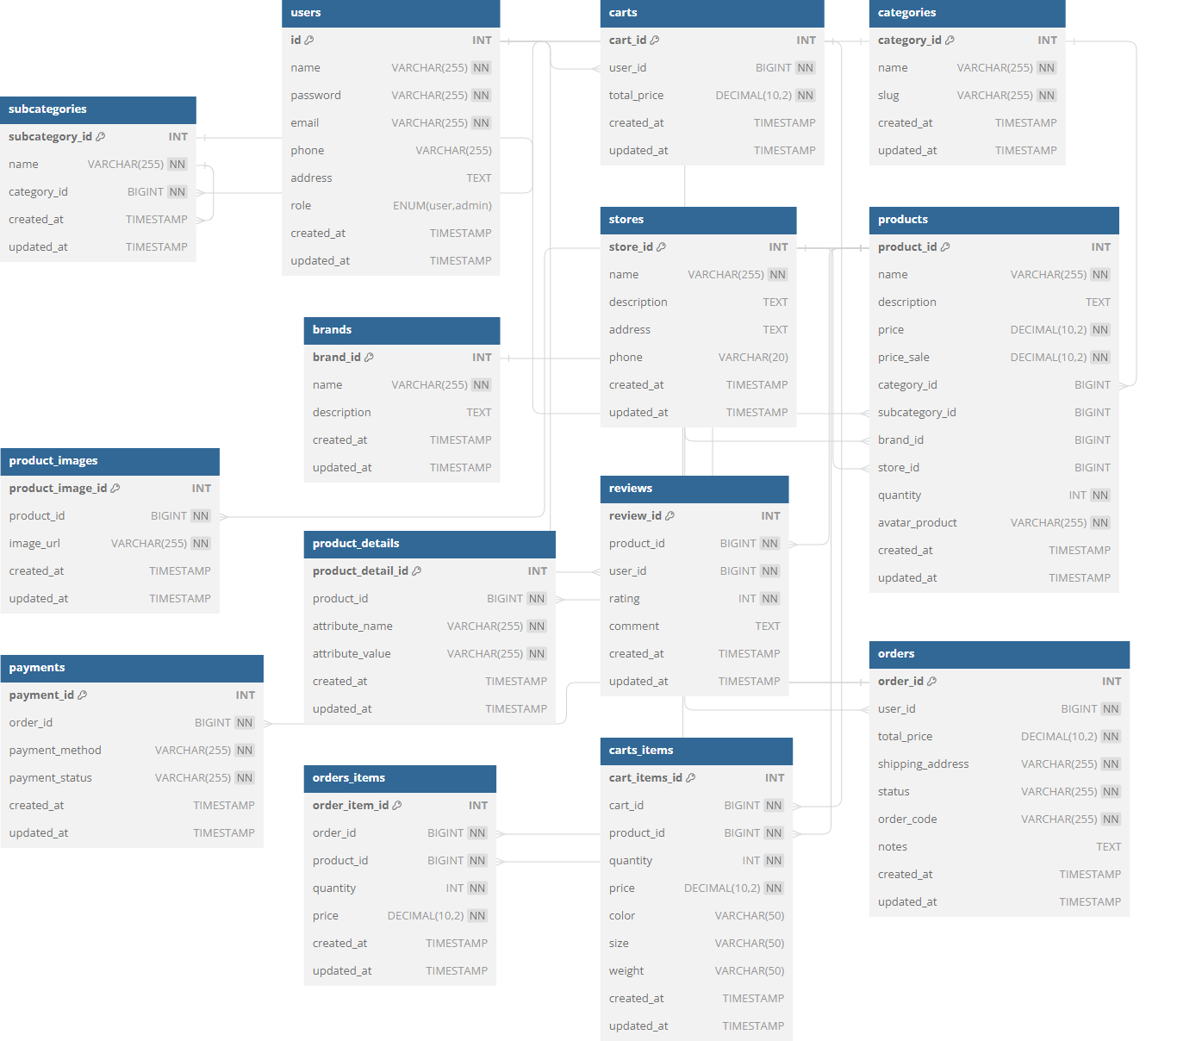

|  |  |  |
| --- | --- | --- |
| USER | | |
| FIELD | DATATYPE | CONSTRAINT |
| ID | INT | Primary Key, NOT NULL, auto increment |
| Name | VARCHAR(255) | NOT NULL |
| Password | VARCHAR(255) | NOT NULL |
| Email | VARCHAR(255) | NOT NULL |
| Phone | VARCHAR(255) |  |
| Address | TEXT |  |
| Role | ENUM |  |
| Create_at | TIMESTAMP |  |
| Update_at | TIMESTAMP |  |

|  |  |  |
| --- | --- | --- |
| STORES | | |
| FIELD | TYPE | CONSTRAINT |
| Stores_id | INT | Primary Key, NOT NULL, auto increment |
| Name | VARCHAR(255) | NOT NULL |
| Description | TEXT |  |
| Address | TEXT |  |
| Phone | VARCHAR(20) |  |
| Created_at | TIMESTAMP |  |
| Updated_at | TIMESTAMP |  |

|  |  |  |
| --- | --- | --- |
| BRANDS | | |
| FIELD | TYPE | CONSTRAINT |
| Brand_id | INT | Primary Key, NOT NULL, auto increment |
| Name | VARCHAR(255) | NOT NULL |
| Description | TEXT |  |
| Created_at | TIMESTAMP |  |
| Updated_at | TIMESTAMP |  |

|  |  |  |
| --- | --- | --- |
| PRODUCTS | | |
| FIELD | TYPE | CONSTRAINT |
| Product_id | INT | Primary Key, NOT NULL, auto increment |
| Name | VARCHAR(255) | NOT NULL |
| description | TEXT |  |
| Price | DECIMAL(10,2) | NOT NULL |
| Price_sale | DECIMAL(10,2) | NOT NULL |
| Category_id | BIGINT |  |
| Subcategory_id | BIGINT |  |
| Brand_id | BIGINT |  |
| Store_id | BIGINT |  |
| Quantity | INT | NOT NULL |
| Avatar_product | VARCHAR(255) | NOT NULL |
| Created_at | TIMESTAMP |  |
| Updated_at | TIMESTAMP |  |

|  |  |  |
| --- | --- | --- |
| CATEGORIES | | |
| FIELD | TYPE | CONSTRAINT |
| Category_id | INT | Primary Key, NOT NULL, auto increment |
| Name | VARCHAR(255) | NOT NULL |
| Slug | VARCHAR(255) | NOT NULL |
| Created_at | TIMESTAMP |  |
| Updated_at | TIMESTAMP |  |
| SUBCATEGORIES | | |
| FIELD | TYPE | CONSTRAINT |
| Subcategory_id | INT | Primary Key, NOT NULL, auto increment |
| Name | VARCHAR(255) | NOT NULL |
| Category_id | BIGINT | NOT NULL |
| Created_at | TIMESTAMP |  |
| Update_at | TIMESTAMP |  |

|  |  |  |
| --- | --- | --- |
| PRODUCT_IMAGES | | |
| FIELD | TYPE | CONSTRAINT |
| Product_image_id | INT | Primary Key, NOT NULL, auto increment |
| Product_id | BIGINT | NOT NULL |
| Image_url | VARCHAR(255) | NOT NULL |
| Created_at | TIMESTAMP |  |
| Update_at | TIMESTAMP |  |

|  |  |  |
| --- | --- | --- |
| PAYMENTS | | |
| FIELD | TYPE | CONSTRAINT |
| Payment_id | INT | Primary Key, NOT NULL, auto increment |
| Oder_id | BIGINT | NOT NULL |
| Payment_method | VARCHAR(255) | NOT NULL |
| Payment_status | VARCHAR(255) | NOT NULL |
| Created_at | TIMESTAMP |  |
| Update_at | TIMESTAMP |  |

|  |  |  |
| --- | --- | --- |
| PRODUCT_DETAILS | | |
| FIELD | TYPE | CONSTRAINT |
| Product_detail_id | INT | Primary Key, NOT NULL, auto increment |
| Product_id | BIGINT | NOT NULL |
| Attribute_name | VARCHAR(255) | NOT NULL |
| Attribute_value | VARCHAR(255) | NOT NULL |
| Created_at | TIMESTAMP |  |
| Update_at | TIMESTAMP |  |

|  |  |  |
| --- | --- | --- |
| ODERS_ITEMS | | |
| FIELD | TYPE | CONSTRAINT |
| Order_item_id | INT | Primary Key, NOT NULL, auto increment |
| Oder_id | BIGINT | NOT NULL |
| Product_id | BIGINT | NOT NULL |
| Quantity | INT | NOT NULL |
| Price | DECIMAL(10,2) | NOT NULL |
| Created_at | TIMESTAMP |  |
| Updated_at | TIMESTAMP |  |

|  |  |  |
| --- | --- | --- |
| CARTS | | |
| FIELD | TYPE | CONSTRAINT |
| Cart_id | INT | Primary Key, NOT NULL, auto increment |
| User_id | BIGINT | NOT NULL |
| Total_price | DECIMAL(10,2) | NOT NULL |
| Created_at | TIMESTAMP |  |
| Updated_at | TIMESTAMP |  |

|  |  |  |
| --- | --- | --- |
| REVIEWS | | |
| FIELD | TYPE | CONSTRAINT |
| Review_id | BIGINT | Primary Key, NOT NULL, auto increment |
| Product_id | BIGINT | NOTNULL |
| User_id | BIGINT | NOT NULL |
| Rating | INT | NOT NULL |
| Comment | TEXT |  |
| Created_at | TIMESTAMP |  |
| Updated_at | TIMESTAMP |  |

|  |  |  |
| --- | --- | --- |
| ORDERS | | |
| FIELD | TYPE | CONSTRAINT |
| Order_id | INT | Primary Key, NOT NULL, auto increment |
| User_id | BIGINT | NOT NULL |
| Total_price | DECIMAL(10,2) | NOT NULL |
| Shipping_address | VARCHAR(255) | NOT NULL |
| Status | VARCHAR(255) | NOT NULL |
| Order_code | VARCHAR(255) | NOT NULL |
| Notes | TEXT |  |
| Created_at | TIMESTAMP |  |
| Updated_at | TIMESTAMP |  |

|  |  |  |
| --- | --- | --- |
| CARTS_ITEMS | | |
| FIELD | TYPE | CONSTRAINT |
| ID | INT | Primary Key, NOT NULL, auto increment |
| Cart_id | BIGINT | NOT NULL |
| Product_id | BIGINT | NOT NULL |
| Quantity | INT | NOT NULL |
| Price | DECIMAL(10,2) | NOT NULL |
| Color | VARCHAR(50) |  |
| Size | VARCHAR(50) |  |
| Weight | VARCHAR(50) |  |
| Created_at | TIMESTAMP |  |
| Updated_at | TIMESTAMP |  |

## Sitemap

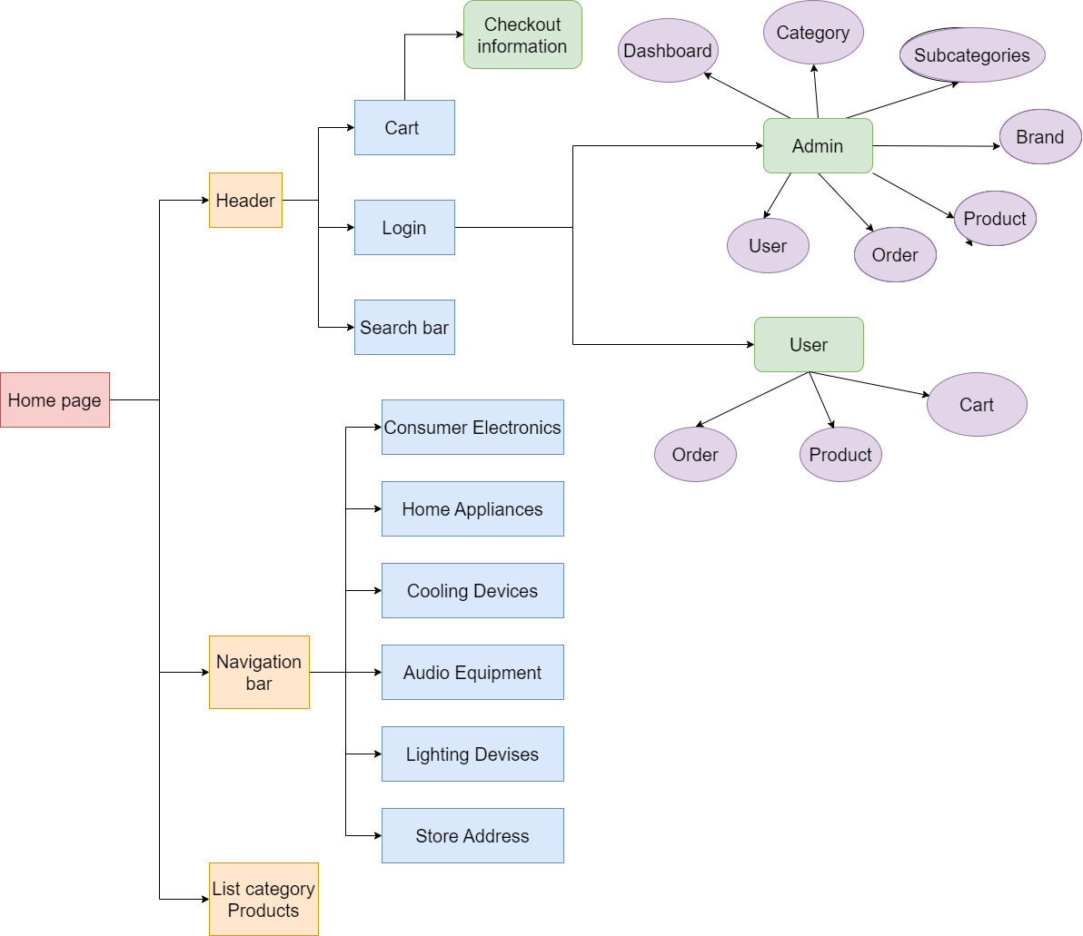

## System fucntions design

### 3.4.1. Resgistration

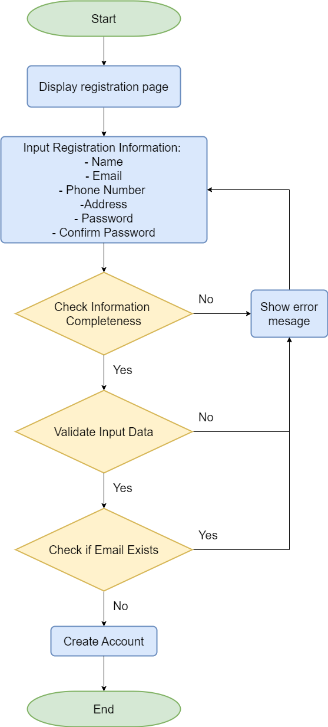

### 3.4.2. Login

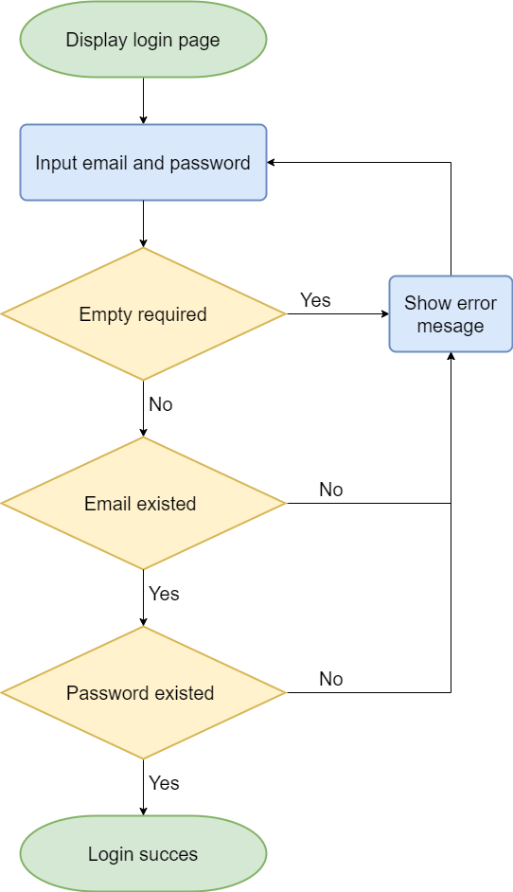

### 3.4.3. Checkout

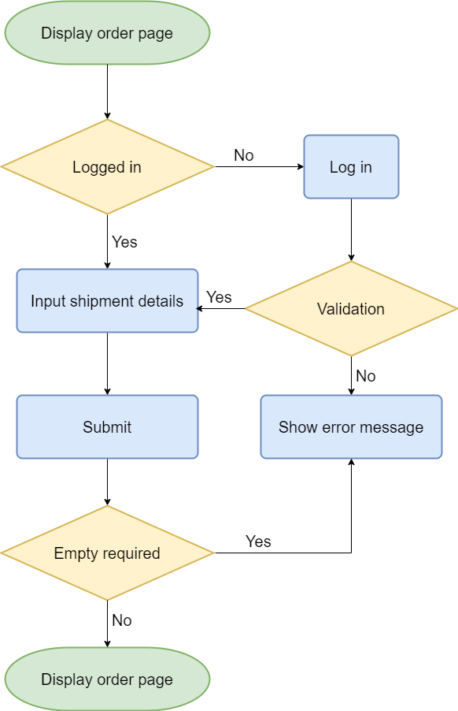

# Task sheet

|  |  |  |  |  |
| --- | --- | --- | --- | --- |
| **Task** | **Start Time** | **Finish Time** | **Implemented by** | **Evaluation (%)** |
| **0)Analyze tasks** | **17/07/2024** | **21/07/2024** | **Team** | **100** |
| Brainstorm the task | 17/07/2024 | 21/07/2024 | Hieu Phi Van | 100 |
| **I)Project Initialization** | **21/07/2024** | **25/07/2024** | **Team** | **100** |
| 1. Set Up Environtment   (install PHP, Laravel, ReactJS,git) | 21/07/2024 | 23/07/2024 | Dung Nguyen Duc | 33 |
| 1. Create Project Directory Structure, folder   (backend,frontend,database) | 21/07/2024 | 23/07/2024 | Hue Nguyen Thi | 33 |
| 1. Set Up Database   (Create tables, constraints,primarykey,foreign keys) | 23/07/2024 | 25/07/2024 | Hieu Tran The | 33 |
| **II) Backend Development(Laravel)**  **(Admin Dashboard,Api React)** | **25/07/2024** | **01/08/2024** | **Team** | **100** |
| **1.Admin Dashboard** | **25/07/2024** | **28/07/2024** | **Team** | **100** |
| a.1) Authentication & Authorization(backend) | 25/07/2024 | 26/07/2024 | Hieu Phi Van | 5 |
| a.2)Authentication & Authorization(frontend-view) | 26/07/2024 | 27/07/2024 | Hieu Phi Van | 5 |
| b.1) Category Management (backend) | 25/07/2024 | 26/07/2024 | Hieu Phi Van | 10 |
| b.2) Category Management (frontend-view) | 26/07/2024 | 27/07/2024 | Hieu Tran The | 5 |
| c.1) Subcategory anagement  (backend) | 25/07/2024 | 26/07/2024 | Hieu Phi Van | 10 |
| c.1) Subcategory anagement  (frontend-view) | 26/07/2024 | 27/07/2024 | Hue Nguyen Thi | 5 |
| d.1) Brand Management  (backend) | 25/07/2024 | 26/07/2024 | Hieu Phi Van | 10 |
| d.1) Brand Management  (frontend-view) | 26/07/2024 | 27/07/2024 | Dung Nguyen Duc | 5 |
| e.1) Product Management  (backend) | 25/07/2024 | 26/07/2024 | Hieu Phi Van | 10 |
| e.2) Product Management  (frontend-view) | 26/07/2024 | 27/07/2024 | Hieu Phi Van | 5 |
| f.1) Order Management  (backend) | 27/07/2024 | 28/07/2024 | Hieu Phi Van | 10 |
| f.2) Order Management  (frontend-view) | 27/07/2024 | 28/07/2024 | Hieu Phi Van | 5 |
| g.1) User Management  (backend) | 27/07/2024 | 28/07/2024 | Hieu Phi Van | 10 |
| g.1) User Management  (frontend-view) | 27/07/2024 | 28/07/2024 | Hieu Phi Van | 5 |
| **2.API REACT** | **28/07/2024** | **01/08/2024** | **Team** | **100** |
| a) Authentication & Authorization | 28/07/2024 | 30/08/2024 | Hieu Phi Van | 20 |
| b) Api Product Management | 28/07/2024 | 30/08/2024 | Hieu Phi Van | 20 |
| c) Api Category Management | 28/07/2024 | 30/08/2024 | Hieu Phi Van | 20 |
| d) Api Subcategory Management | 30/07/2024 | 01/08/2024 | Hieu Phi Van | 10 |
| e) Api Brand Management | 30/07/2024 | 01/08/2024 | Hieu Phi Van | 20 |
| f) Api Order Management | 30/07/2024 | 01/08/2024 | Hieu Phi Van | 10 |
| **III) Frontend Development(React)** | **01/08/2024** | **07/08/2024** | **Team** | **100** |
| a) Home page | 01/08/2024 | 03/08/2024 | Hieu Tran The | 10 |
| b) Shop page | 01/08/2024 | 04/08/2024 | Hieu Phi Van | 10 |
| c) Product page | 01/08/2024 | 05/08/2024 | Dung Nguyen Duc | 10 |
| d) Checkout page | 01/08/2024 | 05/08/2024 | Hue Nguyen Thi | 10 |
| e) Address page | 05/08/2024 | 06/08/2024 | Hue Nguyen Thi | 10 |
| f) Profile page | 06/08/2024 | 07/08/2024 | Dung Nguyen Duc | 10 |
| g) Thanksyou page | 07/08/2024 | 08/08/2024 | Hieu Tran The | 10 |
| h) Search page | 07/08/2024 | 08/08/2024 | Hieu Phi Van | 10 |
| i) Cart page | 07/08/2024 | 08/08/2024 | Hieu Tran The | 10 |
| k) Login,Register,Forgot page | 07/08/2024 | 08/08/2024 | Hieu Phi Van | 10 |
| **IV) Testing** | **07/08/2024** | **09/08/2024** | **Team** | **100** |
| Write test cases for backend (Laravel) | 07/08/2024 | 09/08/2024 | Hue Nguyen Thi | 33 |
| Write test cases for frontend (React) | 07/08/2024 | 08/08/2024 | Dung Nguyen Duc | 33 |
| Test integration between frontend and backend | 07/08/2024 | 09/08/2024 | Hieu Tran The | 33 |
| **V)Fìnd Assets** | **09/08/2024** | **10/08/2024** | **Team** | **100** |
| Image product | 09/08/2024 | 10/08/2024 | Hieu Tran The | 33 |
| Image product | 09/08/2024 | 10/08/2024 | Hue Nguyen Thi | 33 |
| Image product | 09/08/2024 | 10/08/2024 | Dung Nguyen Duc | 33 |
| **VI) Documentation & Report** | **10/08/2024** | **15/08/2024** | **Team** | **100** |
| a) Problem Definition | 10/08/2024 | 13/08/2024 | Hue Nguyen Thi | 20 |
| b) Customer Requirements | 10/08/2024 | 13/08/2024 | Dung Nguyen Duc | 20 |
| c.1) System Designs | 10/08/2024 | 13/08/2024 | Hieu Tran The | 20 |
| c.2) System Designs | 10/08/2024 | 13/08/2024 | Hue Nguyen Thi | 20 |
| d) Task sheet | 13/08/2024 | 15/08/2024 | Hieu Phi Van | 10 |
| e) Validation | 13/08/2024 | 15/08/2024 | Hieu Phi Van | 10 |

# Validation Checklists

Valiate data: register form – login form:

+register

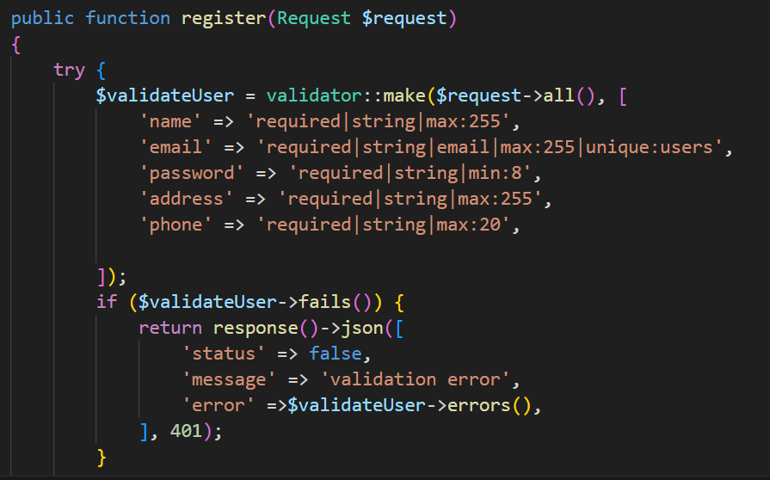

+ login

